The Sale and Inventory System of U.S.C.

Requirements Specification

Table of Contents

PROJECT DRIVERS
1. The Purpose of the Product…………………….3
2. Client, Customer and other Stakeholders……..4
3. Users of the Product……………………………..5

PROJECT CONSTRAINTS
4. Mandated Constraints……………………………7
5. Naming Conventions and Definitions………….10
6. Relevant Facts and Assumptions………………10

FUNCTIONAL REQUIREMENTS
7. The Scope of the Work……………………………12
8. The Scope of the Product………………………….4
9. Functional and Data Requirements………………13

NON-FUNCTIONAL REQUIREMENTS
10. Look and Feel Requirements…………………………………………..30
11. Usability Requirements……………………………42
12. Performance Requirements……………………………………………45
13. Operational Requirements…………………………………………….51
14. Maintainability and Portability Requirements…………………………………………….58
15. Security Requirements……………………………...60
16. Cultural and Political Requirements…………………………………………….62
17. Legal Requirements…………………………………64

PROJECT ISSUES
18. Open Issues…………………………………………..66
20. New Problems………………………………………...66
21. Tasks…………………………………………………..66
22. Cutover…………………………………………………66
23. Risks……………………………………………………66
24. Costs……………………………………………………..67
25. User Documentation and Training……………………………………………………….67
26. Waiting Room……………………………………………68
27. Ideas for Solutions………………………………………68

1 The Purpose of the Product

1a. The user problem or background to the project effort.

Content
Utility Store Corporation is facing problem to handle their records because they are storing their demand forms, purchase order, price variation list and stock return memo (which is very difficult to handle and maintain). Client wants a system that can handle all their data in a secure and efficient way so that authorize person can only access the data. Client also wants to reduce human efforts. The main problem of the Company is that they are facing corruption client wants to reduce corruption.

Motivation
Client wants to save resources and use them in a optimize way. Client also wants to save time and human effort.

Considerations
User problem is serious. Company main goal is to provide daily life grocery products to poor people at ground level. But because of corruption poor people are not properly able to use these products.

1b. Goals of the product.
Content
The main reason is to store data in a computerized. So that user can easily find the required data whenever it is needed. Client also wants to maintain check and balance.
Motivation
Work for the human providing grocery items.

Fit Criterion
People will buy groceries at low prices and without any corruption.

2 Client, Customer and other Stakeholders
2a. The client is the person/s paying for the development, and owner of the delivered system.

Content
Dr. Mukhtiar Ahmad (USC )
Motivation
The client has the final acceptance of the system, and thus must be satisfied with the system as delivered. Where the system is being developed for in-house consumption, the roles of the client and the customer may be filled by the same person. If you cannot find a name for your client, then perhaps you should not be building the product.
Considerations
Sometimes, when building a package or a product for external users, the client is the marketing department. In this case, a person from the marketing department must be named as the client.

2b. The customer is the person/s who will buy the product from the client.

Content
Customers are the normal people of that area or city.
Motivation
Customer wants to buy daily routine groceries products in low prices.

2c. Other stakeholders

Content

- Procurement Officer
- Store incharge
- Area Manager
- Warehouse incharge
- Zonal Manager
- Companies

- Procurement Officer:
  - Roll is to control inventory of warehouse, generate purchase order against demand draft and generate return report of damage and expire product in warehouses (that received by warehouse incharge).
  - BA and knowledge of computer is mandatory for this job.

- Store incharge:
  - Roll of store incharge is to sale the products maximum. Try to have low inventory and maximum sale.
  - Must pass the F.A. and must have the knowledge of computer.
- Area Manager:
  - Roll of area manager is to control over charging and make sure store incharge is not selling the damage and expire products.
  - Must pass the F.A. and must have the knowledge of computer.
- Warehouse incharge:
  - Roll of warehouse incharge is to send products to store against demand form that is received by area manager.
  - Fill the demand form and submit it to procurement officer.
  - Minimum pass the B.A. and maximum have the degree of M.A. in economics
  - Must have the knowledge of computer.
- Zonal Manager
  - Roll is to control zonal area and to approve purchase orders, transfers and termination of employees.
  - Check and balance sale.
  - Minimum M.A. degree is mandatory.
- Companies:
  - Companies buy their products to the USC.

3 Users of the Product
3a. The Users of the Product
Content:
- Procurement Officer
- Store incharge
- Area Manager
- Warehouse incharge
- Zonal Manager
- Companies

User name: Procurement Officer
User role:
User role is to control inventory of warehouse, generate purchase order against demand draft and generate return report of damage and expire product in warehouses (that received by warehouse incharge).

Subject matter experience:
A minimum criterion is to have BA degree and knowledge of computer is mandatory for this job.
Procurement officer is must be of 16 grade officer.
Technological experience:
Must have experience of 4 years and knowledge of MS Office and also some knowledge of internet.

User name: Store incharge:
User role:
User role is to sale the products maximum. Try to have low inventory and maximum sale.
Subject matter experience:
Minimum criteria is to have degree of F.A. and must have the knowledge of computer.
Store incharge is must be the officer of 9 to 11 grade officer..
Technological experience –
Must have experience of 4 years and knowledge of MS Office and also some knowledge of internet.

User name: Area Manager
User role:
Roll of area manager is to control over charging and make sure store incharge is not selling the damage and expire products.
Subject matter experience:
Minimum criteria is pass the F.A. level and must have the knowledge of computer
Store incharge is must be the officer 16 grade officer..
Technological experience –
Must have experience of 2 years and knowledge of MS Office and also some knowledge of internet.

User name: Warehouse Incharge
User role:
Roll of warehouse incharge is to send products to store against demand form that is received by area manager.
Fill the demand form and submit it to procurement officer.
Subject matter experience:
Minimum criteria the B.A. and maximum have the degree of M.A. in economics
Warehouse incharge is must be the officer 14 grade officer..
Technological experience –
Must have experience of 3 years and knowledge of MS Office and also some knowledge of internet

User name: Zonal Manager
User role:
Roll is to control zonal area and to approve purchase orders, transfers and termination of employees.
Check and balance sale.
Subject matter experience:
Minimum criteria is to must have M.A. degree.
Warehouse incharge is must be the officer 18 grade officer..
Technological experience –
Must have experience of 5 years and knowledge of MS Office and also some knowledge of internet

User name: Comapnies Manager
User role:
Roll is to provide their best quality products to the USC with proper check and balance.
Subject matter experience:
Minimum criteria is that company must have halal food certification.
Technological experience –
Company must have proper computerize system.

Other user characteristics:
Age Group: 25 to 55
Gender: Male and Female both can do that job.

Physical abilities/disabilities: Physically must be normal. Disable people cannot do these jobs.
Language: Must know how to speak Urdu and English.

3b. The priorities assigned to users
Content:

Key Users.
  - Procurement Officer
  - Store incharge
  - Area Manager
  - Warehouse incharge
  - Zonal Manager
- Secondary Users
  - Companies

Motivation:
These users are the main and only persons who use this system without them system cannot be work.

4 Mandated Constraints
This section describes constraints on the requirements and the eventual design of the product.

4a. Solution Constraints
Content
- Each area manager cannot supervise more than 12 store.
- Each area manager can view only those 12 stores, which he is supervising.
- Each store Incharge can only view data of his store.
- Each warehouse Incharge can only view data of his warehouse.
- Zonal Manager must be able to view the overall progress of his zone and also there is only 1 Zonal manager of each zone.
- Each stakeholder must go through authentication procedure like user name and password.
- Username and password must be allotted to each stakeholder according to its designation.
Motivation
These are constraints that must be part of the final product of our system.
Considerations
We are not developing the whole system of the USC. We are just developing the system just for their Sales purchase and inventory.

4b. Implementation Environment
Content
We will use MySQL for the creating the database for this system and we will use java language for designing its interface and establish connection between database and interfaces.
Motivation
To describe the technological environment into which the product must fit.
The environment places design constraints on the product. This part of the specification provides enough information about the environment for the designers to make the product successfully interact with its surrounding technology.
The operational requirements are derived from this description.
The system which we are using for the implementation of this system should be Intel core i3 have installed java development tool in it like eclipse or net beans, and for the creating database for this system it should have MySQL and MySQL Yog Ultimate.
Considerations
The data that we have extracted from their demand form, purchase order, stock return memo, receipt should be implemented in the this phase.

4c. Partner Applications

Content
Account department that is not a part of our system directly but they are also keeping track of our sales.

Motivation
They are just handling financial resources of the organization.

Considerations
They create salary slip every month for each employ of the organization, and manage the whole financial resources of organization.

4e. Anticipated Workplace Environment

Content
User will use the product in the environment of store and office. In store the environment is dusty and not clean so clean very much. The workplace like offices has no dusty area. Somehow the little dusty area in the store will cause some problem in the hardware which also cause reduction of the efficiency.
The printer is a considerable distance from the user’s desk. This constraint suggests that printed output should be de-emphasized.

Motivation
This information help the user and engineers to increase the efficiency of product.

Considerations
The product should overcome whatever difficulties exist, so make sure that these constraints fulfill during the work.
4f. How long do the developers have to build the system?
Content
It will take 4 months to build the system. This time duration is enough for the developers to build the system.

Motivation:
If we don’t build the system then USC can sue us and make us able to pay them.
If we build the in the time given then USC pay us with agreed price.

4g. What is the financial budget for the system?
This is an academic project, so we cannot calculate the financial budget of this system.
5 Naming Conventions and Definitions
This section gives definitions of all terms, including acronyms, used in the project.

Content

Abbreviation/Names | Meaning
USC | Utility stores Corporation.
MD | Managing director of the organization.
Demand form | store’s Incharge use it to get products from its warehouse  and warehouse Incharge use it to tell Zonal manager  which are the items that he need to fill his inventory.
PO | Purchase Order, it is used to buy products form different  companies for their inventory.
Stock return memo | It is used to return or exchange product that are expired or damage from which company we buy these items.
IF | Interface
ERD | Entity relationship diagram
UC | Usecase
Motivation
These are the Name/abbreviations which we are using in our Requirement document which help peoples to understand them easily.
6 Relevant Facts and Assumptions

6a. Assumptions that the team are making about the project.

Content
Assumptions about new laws or political decisions
Assumptions of interface first we design the interface with assumptions and then we agree on them.
Assumptions about hardware that USC have all required hardware system for the system.

Motivation
We make sure and discuss these assumptions with client and they agree on it.
Considerations
We also make agree that developer team, client and stakeholder will agree on all assumptions. We also make sure that we don’t take wrong assumptions

7 The Scope of the Work

7a. The context of the work
Content:
The systems on context diagram indicate working roll of the people and organizations. The interfaces between the systems and the work context indicate that we are interested in the system of how they manage their stock and sale.

Motivation
Each person work on the its each boundaries no stockholder can interfere in any other works. The boundary of the system is in the USC.
Considerations
Procurement Officer, Area Manager, Store Inhcarge, Compcoany , Customer, Product, and Employee are to be consider and each work on its boundary.

8 The Scope of the Product
8a. Product Boundary
Use case diagram identifies boundaries between the users and product.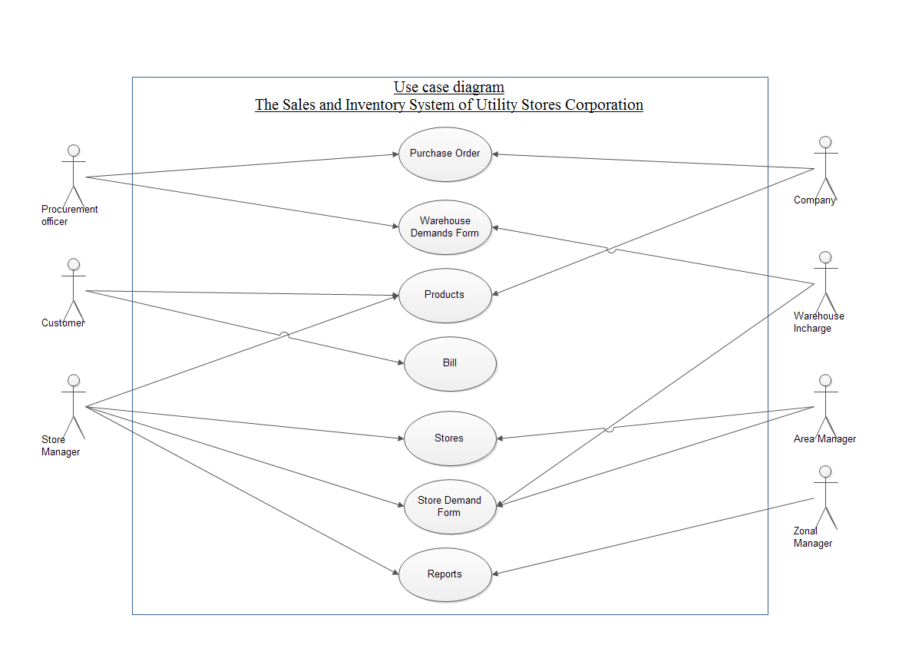
8a. Use Case
The use case diagram is a graphical way of summarizing all the use cases relevant to the product. If you have a large number of use cases, we find 15-20, is around the limit, then it is better to list the use cases and model each one individually. For each use case on the list you should have: use case number, user/actor name, use case description and use case fit criterion.
Also if you have built a use case description and/or any scenario models for this use case then this list can point to them.

Example
Use Case: UC01
User/actor name
Procurement Officer, Company, Customer, Zonal Manager, Area Manager, Store Incharge and Warehouse Inchagre.
Description
Every store must be under store incharge. Store incharge is the head of that store.
Store incharge fill demand form and submit it to its area manager.
Area manager after approval forward the demand form to warehouse incharge which is collected from store incharge.
After collecting demand form from area manager warehouse incharge deliver goods to that particular store.
If warehouse incharge do not have enough goods then warehouse incharge fill the demand form and submit it to procurement officer.
Procurement officer generate purchase order for required company against that demand form submitted by warehouse inhcarge.
Zonal Manager must approve purchase order.
Company deliver good to warehouse.
Store incharge can view inventory and see reports.
Customer buy products and receive bill.
Zonal Manager can see reports.
Fit Criterion
Bill shall be used by the customer and stores records.
Demand form is go through by area manager, zonal manager and warehouse incharge.
Demand form shall have all authorized persons approval.
Company shall provide good quality products.
Procurement officer shall generate purchase order if goods are not available in the warehouse or the records are not in required quantity.
Warehouse incharge shall receive company receipt and inform superiors about the goods.
.

Use Case Scenarios
The description for the use case describes the normal way that it operates.

9 Functional and Data Requirements
9a. Functional Requirements:

Content:

Requirement #: 0001
Requirement Type: 9
Event/use case #: UC01
Description: Each Store must be control by one store incharge.
Rationale: To be able to run store under one person who is selected by the proper procedure and knows about the store.
Motivation: Every store must be under store incharge. Store incharge is the head of that store.
Source: Muhammad Saleem, Nouman Baig- Area Manager
Fit Criterion: Each store manager must have junior staff and must update each record on available net service. Store will run under one store incharge. Or the required item is running item that use much.
Dependencies: All requirements using road and scheduling data.
Supporting Materials: Work context diagram, terms definitions section 5
Customer Satisfaction: 4
Customer Dissatisfaction: 0
History: Created April 10,2015

Requirement #: 0002
Requirement Type: 9
Event/use case #: UC01
Description: Store incharge fill demand form and submit it to its area manager.
Rationale: Demand form able the officers to request for the require items.
Source: Muhammad Saleem, Nouman Baig – Area Manager
Fit Criterion: Store incharge will fill demand form if stock will be out of range or soon stock will be finish.
Supporting Materials: Manual demand form.
Customer Satisfaction: 5
Customer Dissatisfaction: 0
History: Created April 10,2015

Requirement #: 0003
Requirement Type: 9
Event/use case #: UC01
Description: Area manager after approval forward the demand form to warehouse incharge which is collected from store incharge.
Rationale: A justification of the requirement

Source: Muhammad Saleem, Nouman Baig -Area Manager
Fit Criterion: Area manager must check the demand form and check if there is anything missing. Area manager approve the demand form by checking proper record of that items.
Dependencies: 0002
Supporting Materials: Demand form
Customer Satisfaction: 5
Customer Dissatisfaction: 0
History: Created April 10,2015

Requirement #: 0004
Requirement Type: 9
Event/use case #: UC01
Description: After collecting demand form from area manager warehouse incharge deliver goods to that particular store.
Rationale: Warehouse incharge take the copy of that demand draft which must be approve by area manager and store incharge so that warehouse inhcarge have proper authorization to send stock to store inhcarge.
Source: Muhammad Saleem, Nouman Baig -Area Manager
Fit Criterion: Warehouse incharge shall check that demand form must have all required approval and demand form must be approved by all authorized person.
Dependencies: 0002
0003
Supporting Materials: Demand form
Customer Satisfaction: 4
Customer Dissatisfaction: 0
History: Created April 10,2015

Requirement #: 0005
Requirement Type: 9
Event/use case #: UC01
Description: If warehouse incharge do not have enough goods then warehouse incharge fill the demand form and submit it to procurement officer.
Rationale: If the warehouse stock for the require or desire item then warehouse incharge will fill the demand draft against that demand draft send by store incharge. This demand draft have the warehouse mark that stock is running out and this cause proper procedure which can help to control corruption.
Source: Muhammad Riaz -Warehouse Incharge
Fit Criterion: If there are no required goods available at that time then warehouse incharge shall fill the demand form and entered all detail of item that is require.
Dependencies: 0002
0003
Supporting Materials: Records of the warehouse.
Customer Satisfaction: 5
Customer Dissatisfaction: 1
History: Created April 10,2015

Requirement #: 0006
Requirement Type: 9
Event/use case #: UC01
Description: Procurement officer generate purchase order for required company against that demand form submitted by warehouse inhcarge.
Rationale: Procurement officer have the authority to generate purchase order only procurement officer can generate purchase order but demand draft is compulsory for this.

Source: Tahir Abbas, Amir Ali -Procurement Officer
Fit Criterion: Procurement officer shall check the warehouse stock if warehouse do not have these items then procurement officer generate the purchase order against demand form.
Dependencies: 0002
0003
0005
Supporting Materials: Purchase Order
Customer Satisfaction: 4
Customer Dissatisfaction: 1
History: Created April 10,2015

Requirement #: 0007
Requirement Type: 9
Event/use case #: UC01
Description: Zonal Manager must approve purchase order.
Rationale: Zonal Manager is the head of all the store of one zone. Approval of zonal manager is must for purchase order to maintain proper check and balance.
Source: Tahir Abbas, Amir Ali -Procurement Officer
Fit Criterion: Zonal manager check the purchase order and need of the product before approval.
Supporting Materials: Purchase Order
Customer Satisfaction: 5
Customer Dissatisfaction: 0
History: Created April 10,2015

Requirement #: 0008
Requirement Type: 9
Event/use case #: UC01
Description: After approval of purchase order, purchase order send to that particular company.

Rationale: Purchase order after all authorization and demands of items send to company so that items can be purchase.
Source: Tahir Abbas, Amir Ali -Procurement Officer
Fit Criterion: Purchase order must have detail information of require item and the company information. Company must be the that company which is registered by the Government.
Dependencies: 0007
Supporting Materials: Dummy Purchase Order
Customer Satisfaction: 4
Customer Dissatisfaction: 1
History: Created April 10,2015

Requirement #: 0009
Requirement Type: 9
Event/use case #: UC01
Description: Company deliver good to warehouse.
Rationale: After following procedure company deliver goods only to warehouse so that stock can be safe and fresh as required.
Source: Muhammad Riaz -Warehouse Inhcarge
Fit Criterion: Company check the stock quantity and time of delivery. If stock is available then company deliver the goods to the warehouse.
Dependencies: 0007
0008
Supporting Materials: Warehouse slip of receiving goods.
Customer Satisfaction: 5
Customer Dissatisfaction: 0
History: Created April 10, 2015

Considerations
Event/use case UC01 (see page number # )

9b. Data Requirements
Content
Requirement #: 0010
Requirement Type: 9
Event/use case #: Figure ERD1 and Figure ERD2:
Description: Employee record should have first name, last name, Date of birth, sex, father’s name, designation, CNIC number, BPS, email id, address, and employee mobile number.
Rationale: Employee record is very mandatory for cooperation. Cooperation needs to know each employee personal information and working hours.
Source: Dr. Mukhtiar Ahmad (MD of USC)
Fit Criterion: Each personal information of employee will be store in the same way and they can be easily retrieved.
Dependencies: No one
Conflicts: No one
Supporting Materials: Dummy record
Customer Satisfaction: 5
Customer Dissatisfaction: 0
History: Created April 10, 2015
Requirement #: 0011:
Requirement Type: 9
Event/use case #: Figure ERD1 and Figure ERD2::
Description: Each employee must have each unique id.
Rationale: So that employee can be uniquely identify and must not create mess with same name.
Source: Dr. Mukhtiar Ahmad (MD of USC)
Fit Criterion: Each employee will login with unique id.
Dependencies: 0010
Conflicts: No one
Supporting Materials: Pointer to documents that illustrate and explain this requirement
Customer Satisfaction: 5
Customer Dissatisfaction:0
History: Created April 10, 2015

Requirement #: 0012
Requirement Type: 9
Event/use case #: Figure ERD and Figure ERD2:1:
Description: Each demand form must have form number, date, name of store, region, unit, quantity of that product, and unique item code.
Rationale: Demand form can be easily verify and shall have proper information.
Source: Dr. Mukhtiar Ahmad (MD of USC)
Fit Criterion: Demand form id will not be match with anyone and must have space of other require information related to the product.
Dependencies: 0004
0010
0011
Conflicts: No conflicts
Supporting Materials: Pointer to documents that illustrate and explain this requirement
Customer Satisfaction: 5
Customer Dissatisfaction: 1
History: Created April 10, 2015

Requirement #: 0013
Requirement Type: 9
Event/use case #: Figure ERD and Figure ERD2:1:
Description: Each store must have store name unique store code.
Rationale: Store can be access easily and have unique id. So that store can be identify easily.
Source: Dr. Mukhtiar Ahmad (MD of USC)
Fit Criterion: Each store will easily identify uniquely.
Dependencies: 0010
0010
0011
0012
Conflicts: No Conflict
Supporting Materials: Dummy records
Customer Satisfaction: 5
Customer Dissatisfaction: 0
History: Created April 10, 2015

Requirement #: 0014
Requirement Type: 9
Event/use case #: Figure ERD1 and Figure ERD2
Description: Each store must have name, store incharge name, area manager, store number, category, and incharge mobile number.
Rationale: Store address and name, category, region like information is the require information for every person and cooperation.
Source: Dr. Mukhtiar Ahmad (MD of USC)
Fit Criterion: Different stores in the region will have name, address and store incharge so that record can be easily handle.
Dependencies: 0013
0001
Conflicts: No one
Supporting Materials: Dummy record
Customer Satisfaction: 4
Customer Dissatisfaction: 0
History: Created April 10, 2015

Requirement #: 0015:
Requirement Type: 9
Event/use case #: Figure ERD1 and Figure ERD2
Description: Each purchase order must have unique P.O. number.
Rationale: Unique P.O. number help to retrieve information and uniquely identify .
Source: Dr. Mukhtiar Ahmad (MD of USC)
Fit Criterion: All purchase orders will be easily identify.
Dependencies: 0013
0006
0007
Conflicts: No one
Supporting Materials: Dummy record
Customer Satisfaction: 5
Customer Dissatisfaction: 1
History: Created April 10, 2015

Requirement #: 0016
Requirement Type: 9
Event/use case #: Figure ERD1 and Figure ERD2
Description: Each purchase order must have unique item code.
Rationale: Unique item code make easy to identify and search items.
Source: Dr. Mukhtiar Ahmad (MD of USC)
Fit Criterion: In every purchase order there are list of items and every items are uniquely identifying by unique item code,
Dependencies: 0013
0006
0007
Conflicts: No one
Supporting Materials: Dummy record
Customer Satisfaction: 4
Customer Dissatisfaction: 0
History: Created April 10, 2015

Requirement #: 0017
Requirement Type: 9
Event/use case #: Figure ERD1 and Figure ERD2
Description: Purchase order must have case packing, amount, rate, unit, date of issue, quantity and description.
Rationale: This requirement will not lead to wrong interpretation of items and clarify amount, unit and other required things.
Source: Dr. Mukhtiar Ahmad (MD of USC)
Fit Criterion: All items reach to warehouse because of the information written on the purchase order.
Dependencies: 0013
0016
0006
0007
Conflicts: No one
Supporting Materials: Dummy record
Customer Satisfaction: 4
Customer Dissatisfaction: 0
History: Created April 10, 2015

Requirement #: 0018
Requirement Type: 9
Event/use case #: Figure ERD1 and Figure ERD2
Description: Company data must have unique code
Rationale: Unique code make easy to identify the company and its data.
Source: Dr. Mukhtiar Ahmad (MD of USC)
Fit Criterion: Company found easily with unique code in the list of several companies.
Dependencies: 0008
0009
Conflicts: No one
Supporting Materials: Dummy record
Customer Satisfaction: 4
Customer Dissatisfaction: 1
History: Created April 10, 2015
.

Requirement #: 0019
Requirement Type: 9
Event/use case #: Figure ERD1 and Figure ERD2
Description: Each company must have name, address, description, attention name, phone number and attention phone number.
Rationale: The information that a company must have and it shows the company existence.
Source: Dr. Mukhtiar Ahmad (MD of USC)
Fit Criterion: Contact to company by all their information they provide and reach the company is become easy.
Dependencies: 0018
0007
0008
Conflicts: No one
Supporting Materials: Dummy record
Customer Satisfaction: 4
Customer Dissatisfaction: 1
History: Created April 10, 2015

Requirement #: 0020
Requirement Type: 9
Event/use case #: Figure ERD1 and Figure ERD2
Description: Each product must have unique product code and description.

Rationale: Unique product code make product traceable and description make easy to identify the product features.
Source: Dr. Mukhtiar Ahmad (MD of USC)
Fit Criterion: Require product is identify by the unique product code from the list of products and description help to know the information of product.
Dependencies: 0018
0007
0008
0019
Conflicts: No one
Supporting Materials: Dummy record
Customer Satisfaction: 4
Customer Dissatisfaction: 1
History: Created April 10, 2015

Requirement #: 0021
Requirement Type: 9
Event/use case #: Figure ERD1 and Figure ERD2::
Description: Each product category must have unique id and description.
Rationale: A product have many categories so unique id of category helps to identify category of product and description make it easy to know something about category of product.
Source: Dr. Mukhtiar Ahmad (MD of USC)

Fit Criterion: From the many categories of products the require product is easily searchable.
Dependencies: 0018
0007
0008
0019
0020
Conflicts: No one
Supporting Materials: Dummy record
Customer Satisfaction: 4
Customer Dissatisfaction: 1
History: Created April 10, 2015

Requirement #: 0022
Requirement Type: 9
Event/use case #: Figure ERD1 and Figure ERD2
Description: Each customer must have unique customer id.
Rationale: Customer can be identify by unique customer id so that it make easy to maintain record of each customer.
Source: Dr. Mukhtiar Ahmad (MD of USC)
Fit Criterion: If the customer pick the wrong things so by customer id identification helps to make a solution.
Dependencies: 0020
0021
Conflicts: No one
Supporting Materials: Pointer to documents that illustrate and explain this requirement
Customer Satisfaction: 4
Customer Dissatisfaction: 0
History: Created April 10, 2015

Requirement #: 0023
Requirement Type: 9
Event/use case #: Figure ERD1 and Figure ERD2
Description: Each warehouse must have unique id, name and description.
Rationale: Warehouse can identify by unique id and with name (which can be same) and description.
Source: Dr. Mukhtiar Ahmad (MD of USC)
Fit Criterion: Store incharge knows to contact which warehouse and it helps other to reach the warehouse.
Dependencies: 0002
0016
Conflicts: No one
Supporting Materials: Pointer to documents that illustrate and explain this requirement
Customer Satisfaction: 4
Customer Dissatisfaction: 1
History: Created April 10, 2015

Requirement #: 0024
Requirement Type: 9
Event/use case #: Figure ERD1 and Figure ERD2
Description: Each warehouse demand form must have unique form id, date, description and stock position.
Rationale: Demand form can uniquely identify by the form id and others important information related to the demand form.
Source: Dr. Mukhtiar Ahmad (MD of USC)
Fit Criterion: Demand form is easily traceable form the list of many demand forms.
Dependencies: 0002
0003
Conflicts: No one
Supporting Materials: Dummy record
Customer Satisfaction: 5
Customer Dissatisfaction: 1
History: Created April 10, 2015

Requirement #: 0025
Requirement Type: 9
Event/use case #: Figure ERD1 and Figure ERD2::
Description: Each warehouse demand form must have unique item code.
Rationale: In the demand form unique item code identifying the items that are require.
Source: Dr. Mukhtiar Ahmad (MD of USC)
Fit Criterion: All demand forms have a lot of items by unique item code.
Dependencies: 0002
0003
0008
Conflicts: No one
Supporting Materials: Dummy record
Customer Satisfaction: 5
Customer Dissatisfaction: 1
History: Created April 10, 2015

Requirement #: 0026
Requirement Type: 9
Event/use case #: Figure ERD1 and Figure ERD2::
Description: Each bill must have unique bill id and unique item code
Rationale: To make sure that every customers are identifying by their bill and unique item code helps to manage the stock.
Source: Who raised this requirement?
Fit Criterion: All bills have unique code and items code and if customer wants to return or to keep record of stock and payment bill will help.
Dependencies: 0025
Conflicts: No one
Supporting Materials: Dummy record
Customer Satisfaction: 4
Customer Dissatisfaction:1
History: Created April 10, 2015

Requirement #: 0027
Requirement Type: 9
Event/use case #: Figure ERD1 and Figure ERD2::
Description: Each bill must have date, time, description, rate, quantity, amount and payment type.
.
Rationale: It helps to keep record of customer, employee working hours and maintain check and balance.
Source: Who raised this requirement?
Fit Criterion: Each bill have date, time, description so that customer knows what he buy and USC will know what they sale.
Dependencies: 0025
0026
Conflicts: No one
Supporting Materials: Dummy record
Customer Satisfaction: 5
Customer Dissatisfaction:0
History: Created April 10, 2015

The following is a model of the business data using entity/Relationship modeling notation:
Following is the ER Diagram Figure ERD1:
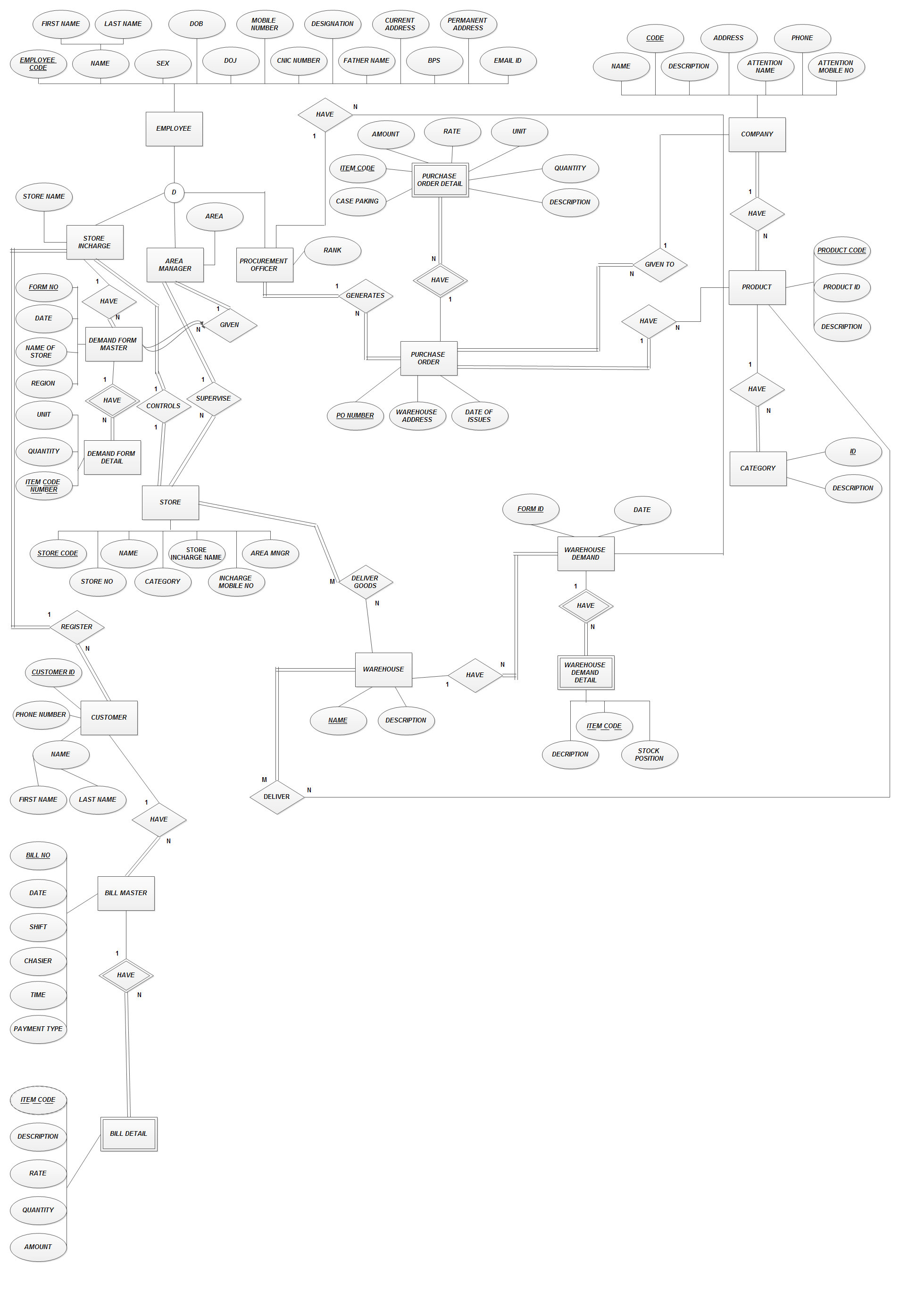

Following is the Relational Diagram with some entity. Figure ERD 2:
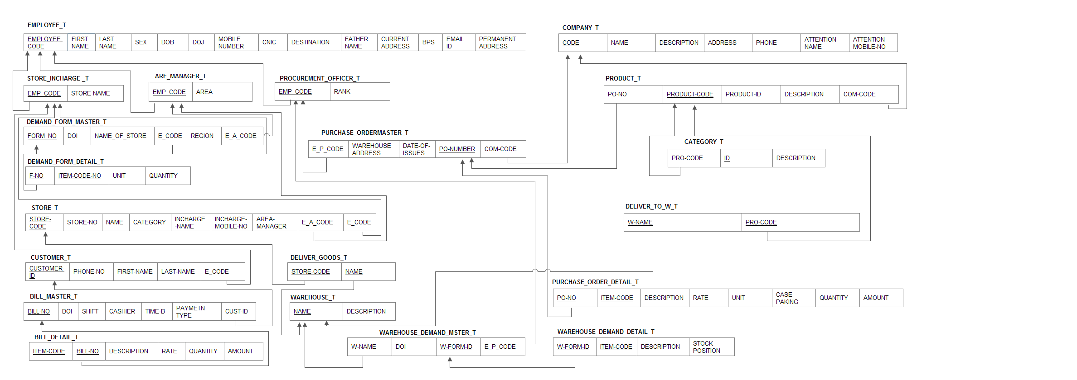
Fit Criterion:

USC require the entity employees, customer, product and other as shown in ERD1 and ERD2. All entities have those attributes which are very helpful and require information for the company. Their relationship are also shown in ERD1.
Employee, Company, Product, Category, Store, Customer, Warehouse Demand and Bill Master are the entities.
1 Bill have many Bill Detail.
1Customer can have many bill master.
1 Warehouse can have many Warehouse Demand Detail.
1 Store can have many Warehouse.
1 Employee can be only Store Incharge or Area Manager or Zonal Manager or Warehouse Incharge or Procurement Officer.
1 Purchase Order can have may Purchase Order Detail.
1 Company can have many Product.
1 Product can have many Categories.
10 Look and Feel Requirements

10a. The interface
Content:

Requirement #: 0028
Requirement Type: 10
Event/use case #: Figure IF01:
Figure IF02:
Figure IF03:
Figure IF04:
Figure IF05:
Figure IF06:
Figure IF07:
Figure IF08:
Figure IF09:
Figure IF10:
Figure IF11:

Description: The product shall have the simple layout.
Rationale: USC is a federal Government Company so they want their layout to be simple.
Source: Procurement Officer
Fit Criterion: All the interface will suit for color blind people and normal people.
Dependencies: No one
Conflicts: No one
Supporting Materials: Paper Prototype
Customer Satisfaction: 4
Customer Dissatisfaction: 1
History: Created April 11, 2015

Requirement #: 0029
Requirement Type: 10
Event/use case #: Figure IF01:
Figure IF02:
Figure IF03:
Figure IF04:
Figure IF05:
Figure IF06:
Figure IF07:
Figure IF08:
Figure IF09:
Figure IF10:
Figure IF11:

Description: The product shall use the company logo
Rationale: Company logo is all they want on every form, bill and interface.
Source: Procurement Officer
Fit Criterion: All bills, interface and forms have logo of USC.
Dependencies: 0028
Conflicts: No one
Supporting Materials: Paper Prototype
Customer Satisfaction: 4
Customer Dissatisfaction: 1
History: Created April 11, 2015

Requirement #: 0030
Requirement Type: 10
Event/use case #: Figure IF01:
Figure IF02:
Figure IF03:
Figure IF04:
Figure IF05:
Figure IF06:
Figure IF07:
Figure IF08:
Figure IF09:
Figure IF10:
Figure IF11:

Description: The product shall be in simple color.
Rationale: USC needs simple color in the interface so that all kind of people can easily use it.
Source: Procurement Officer
Fit Criterion: All interface windows are in simple color.
Dependencies: 0028
0029
Conflicts: No one
Supporting Materials: Paper Prototype
Customer Satisfaction: 4
Customer Dissatisfaction: 1
History: Created April 11, 2015

Requirement #: 0031
Requirement Type: 10
Event/use case #: Figure IF01:
Figure IF02:
Figure IF03:
Figure IF04:
Figure IF05:
Figure IF06:
Figure IF07:
Figure IF08:
Figure IF09:
Figure IF10:
Figure IF11:

Description: The product shall appear goal of the USC.
Rationale: So that all employee will not forget the goal of company.
Source: Procurement Officer
Fit Criterion: USC goal is clear in the window,
Dependencies: 0028
0029
0030
Conflicts: No one
Supporting Materials: Paper Prototype
Customer Satisfaction: 4
Customer Dissatisfaction: 1
History: Created April 11, 2015

Requirement #: 0032
Requirement Type: 10
Event/use case #: Figure IF01:
Figure IF02:
Figure IF03:
Figure IF04:
Figure IF05:
Figure IF06:
Figure IF07:
Figure IF08:
Figure IF09:
Figure IF10:
Figure IF11:

Description: The product shall be visible to color blind people.
Rationale: Color blind employees who are qualified for the job can make easily transaction for the USC.
Source: Procurement Officer
Fit Criterion: Color blind people are using the interface without any hurdle.
Dependencies: A list of other requirements that have some dependency on this one
Conflicts: No one
Supporting Materials: Paper Prototype
Customer Satisfaction: 4
Customer Dissatisfaction: 1
History: Created April 11, 2015

Requirement #: 0033
Requirement Type: 10
Event/use case #: Figure IF01:
Figure IF02:
Figure IF03:
Figure IF04:
Figure IF05:
Figure IF06:
Figure IF07:
Figure IF08:
Figure IF09:
Figure IF10:
Figure IF11:

Description: The product shall appear company logo.
Rationale: USC company logo is an identification symbol of the company so they want their logo to be appear in every form, window and bill.
Source: Procurement Officer
Fit Criterion: All bills, forms and interface have USC logo.
Dependencies: A list of other requirements that have some dependency on this one
Conflicts: No one
Supporting Materials: Paper Prototype
Customer Satisfaction: 4
Customer Dissatisfaction: 1
History: Created April 11, 2015

Considerations
Figure IF01:
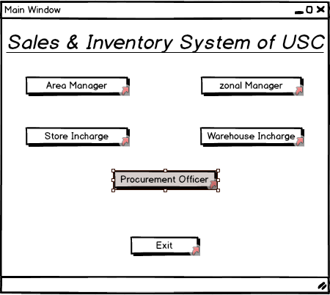.

Figure IF02:

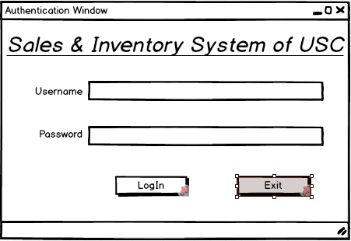

Figure IF03:

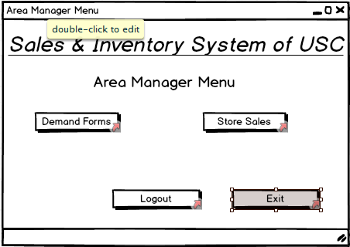

Figure IF04:
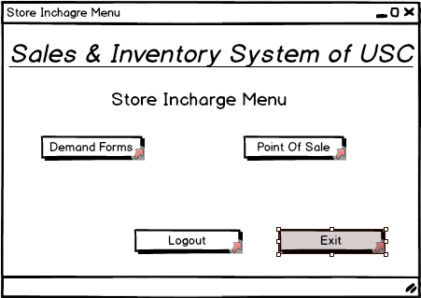

Figure IF05:

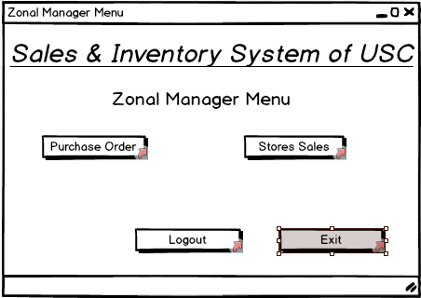

Figure IF06:

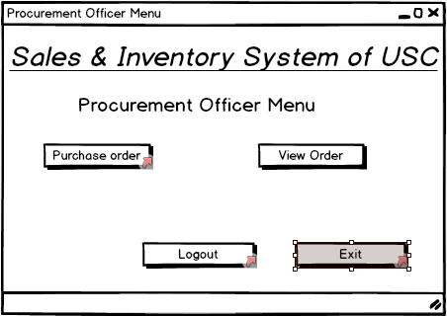

Figure IF07:

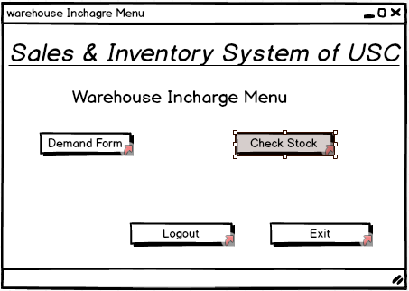
Figure IF08:

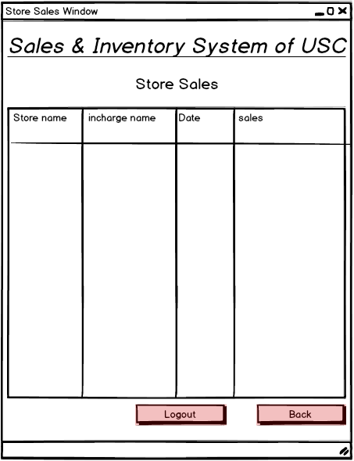
Figure IF09:

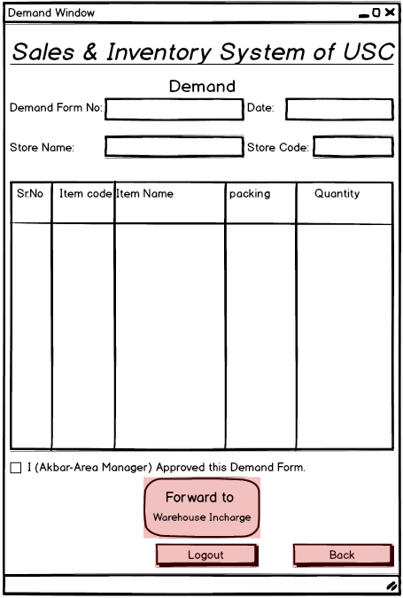

Figure IF10:

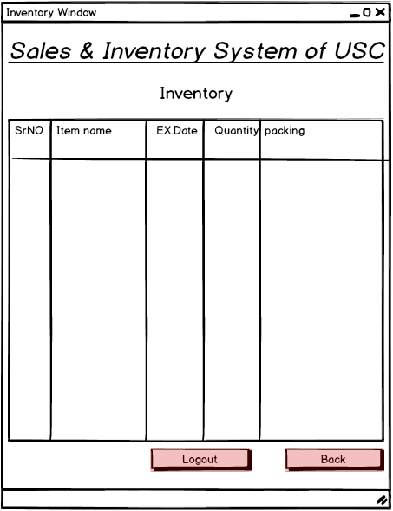

Figure IF11:

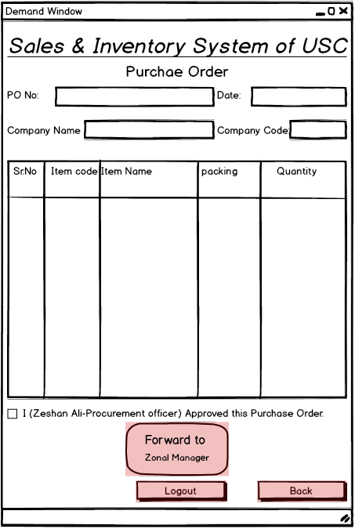

10b. The Style of the Product
Content
Requirement #: 0034
Requirement Type: 10
Event/use case #: Figure IF01:
Figure IF02:
Figure IF03:
Figure IF04:
Figure IF05:
Figure IF06:
Figure IF07:
Figure IF08:
Figure IF09:
Figure IF10:
Figure IF11:

Description: The product is for adult people and it should be plain and simple.
Rationale: USC employees are adult, they are not children and they use simple layout because they want to use them for long period. So that professionals feel no issue to use it.
Source: Procurement Officer
Fit Criterion: Employees have no issue to use it.
Dependencies: 0028
0029
0030
0031
0032
0033
Conflicts: No one
Supporting Materials: Paper Prototype
Customer Satisfaction: 4
Customer Dissatisfaction: 1
History: Created April 11, 2015
.

Motivation
Adult people use only these system so simple layout with many business logic is motivate us to design this interface..
Considerations
See Figure IF01, Figure IF02, Figure IF03, Figure IF04, Figure IF05, Figure IF06, Figure IF07, Figure IF08, Figure IF09, Figure IF10 and Figure IF11

11 Usability Requirements

11a. Ease of Use
Content

Requirement #: 0035
Requirement Type: 11
Event/use case #: Figure IF01:
Figure IF02:
Figure IF03:
Figure IF04:
Figure IF05:
Figure IF06:
Figure IF07:
Figure IF08:
Figure IF09:
Figure IF10:
Figure IF11:

Description: The product shall help the user to avoid making mistakes.
Rationale: Complicated interface can make user mistake and cause problem.
Source: Procurement Officer
Fit Criterion: Employees will perform task with no problem.
Dependencies: 0034
Conflicts: No one
Supporting Materials: Paper Prototype
Customer Satisfaction: 4
Customer Dissatisfaction: 1
History: Created April 11, 2015

Requirement #: 0036
Requirement Type: 11
Event/use case #: Figure IF01:
Figure IF02:
Figure IF03:
Figure IF04:
Figure IF05:
Figure IF06:
Figure IF07:
Figure IF08:
Figure IF09:
Figure IF10:
Figure IF11:

Description: Users shall feel comfortable to use this product.

Rationale: Uncomfortable user will not perform task correctly.
Source: Procurement Officer
Fit Criterion: Employees will perform task with no problem.
Dependencies: 0034
Conflicts: No one
Supporting Materials: Paper Prototype
Customer Satisfaction: 4
Customer Dissatisfaction: 1
History: Created April 11, 2015

Fit Criterion
Client and users finalize these requirement and they are 75% agree to go with these requirements.
Considerations
See Figure IF01, Figure IF02, Figure IF03, Figure IF04, Figure IF05, Figure IF06, Figure IF07, Figure IF08, Figure IF09, Figure IF10 and Figure IF11

11b. Ease of Learning
Content
Requirement #: 0037
Requirement Type: 11
Event/use case #: Figure IF01:
Figure IF02:
Figure IF03:
Figure IF04:
Figure IF05:
Figure IF06:
Figure IF07:
Figure IF08:
Figure IF09:
Figure IF10:
Figure IF11:

Description: An employee shall be able to be productive within a short time.
Rationale: So that not much time taken by the employee.
Source: Procurement Officer
Fit Criterion: Productivity are increasing.
Dependencies: 0034
Conflicts: No one
Supporting Materials: Paper Prototype
Customer Satisfaction: 4
Customer Dissatisfaction: 1
History: Created April 11, 2015

Requirement #: 0038
Requirement Type: 11
Event/use case #: Figure IF01:
Figure IF02:
Figure IF03:
Figure IF04:
Figure IF05:
Figure IF06:
Figure IF07:
Figure IF08:
Figure IF09:
Figure IF10:
Figure IF11:

Description: The product shall be easy for an employee to learn.
Rationale: So that not much time taken by the employee to learn the product.
Source: Procurement Officer
Fit Criterion: Employees are using product with no difficulty.
Dependencies: 0037
Conflicts: No one
Supporting Materials: Paper Prototype
Customer Satisfaction: 4
Customer Dissatisfaction: 1
History: Created April 11, 2015

Motivation
Employees productivity increasing by making simple learnable interface. Which also don’t cause lack of interest.

Fit Criterion
- The product shall be easy for an employee to learn [1 time run] within [15] of beginning to use the product, without needing to use the manual.
- An employee shall be able to be productive within a short time. [1 hour] training a clerk shall be able to produce [increase productivity]
Considerations
See Figure IF01, Figure IF02, Figure IF03, Figure IF04, Figure IF05, Figure IF06, Figure IF07, Figure IF08, Figure IF09, Figure IF10 and Figure IF11

12 Performance Requirements
12a. Speed Requirements
Content
Requirement #: 0039
Requirement Type: 12
Event/use case #: Figure IF01:
Figure IF02:
Figure IF03:
Figure IF04:
Figure IF05:
Figure IF06:
Figure IF07:
Figure IF08:
Figure IF09:
Figure IF10:
Figure IF11:

Description: The product shall update the database on hourly basis.
.
Rationale: So that company stock can update soon.
Source: Procurement Officer
Fit Criterion: Stock is managing timely.
Dependencies: 0037
0008
Conflicts: No one
Supporting Materials: Paper Prototype
Customer Satisfaction: 4
Customer Dissatisfaction: 1
History: Created April 11, 2015

Requirement #: 0040
Requirement Type: 12
Event/use case #: Figure IF01:
Figure IF02:
Figure IF03:
Figure IF04:
Figure IF05:
Figure IF06:
Figure IF07:
Figure IF08:
Figure IF09:
Figure IF10:
Figure IF11:

Description: The response shall be fast enough to avoid interrupting the user’s flow of thought
.
Rationale: So that stock can be managed.
Source: Procurement Officer
Fit Criterion: Stock are managing easily.
Dependencies: 0039
Conflicts: No one
Supporting Materials: Paper Prototype
Customer Satisfaction: 4
Customer Dissatisfaction: 1
History: Created April 11, 2015

Motivation
This products, usually real-time products, must be able to perform these functionality within mention and given time.

Fit Criterion
Unit of measurement is time taken by each process.
Required range of values are 2 seconds and quickly response on database if internet is available.
Considerations
See Figure IF01, Figure IF02, Figure IF03, Figure IF04, Figure IF05, Figure IF06, Figure IF07, Figure IF08, Figure IF09, Figure IF10 and Figure IF11
.

12d. Reliability and Availability Requirements
Content
Requirement #: 0041
Requirement Type: 12
Event/use case #: Figure IF01:
Figure IF02:
Figure IF03:
Figure IF04:
Figure IF05:
Figure IF06:
Figure IF07:
Figure IF08:
Figure IF09:
Figure IF10:
Figure IF11:

Description: The product shall be available for use 24 hours per day, 365 days per year.

.
Rationale: The product can be use all year because people need these product all time.
Source: Procurement Officer
Fit Criterion: Product is using 24 hours per day..
Dependencies: 0040

Conflicts: No one
Supporting Materials: Paper Prototype
Customer Satisfaction: 5
Customer Dissatisfaction: 1
History: Created April 11, 2015

Requirement #: 0042
Requirement Type: 12
Event/use case #: Figure IF01:
Figure IF02:
Figure IF03:
Figure IF04:
Figure IF05:
Figure IF06:
Figure IF07:
Figure IF08:
Figure IF09:
Figure IF10:
Figure IF11:

Description: The product shall be available for use between the hours of 8:00am and 10:00pm.
Rationale: Working hours in the USC
Source: Procurement Officer
Fit Criterion: Product is working efficiently.
Dependencies: 0040
Conflicts: No one
Supporting Materials: Paper Prototype
Customer Satisfaction: 4
Customer Dissatisfaction: 0
History: Created April 11, 2015

Requirement #: 0043
Requirement Type: 12
Event/use case #: Figure IF01:
Figure IF02:
Figure IF03:
Figure IF04:
Figure IF05:
Figure IF06:
Figure IF07:
Figure IF08:
Figure IF09:
Figure IF10:
Figure IF11:

Description: The product shall show detail of errors..
Rationale: So that error can be solve.
Source: Procurement Officer
Fit Criterion: Errors solving are easy.
Dependencies: 0042
0041
Conflicts: No one
Supporting Materials: Paper Prototype
Customer Satisfaction: 4
Customer Dissatisfaction: 2
History: Created April 11, 2015

.
Motivation
These are critical situations and must not be fail.
Fit Criterion
5 seconds are expected time.

Considerations
See Figure IF01, Figure IF02, Figure IF03, Figure IF04, Figure IF05, Figure IF06, Figure IF07, Figure IF08, Figure IF09, Figure IF10 and Figure IF11
12e. Capacity Requirements
Content

Requirement #: 0044
Requirement Type: 12
Event/use case #: Figure IF01:
Figure IF02:
Figure IF03:
Figure IF04:
Figure IF05:
Figure IF06:
Figure IF07:
Figure IF08:
Figure IF09:
Figure IF10:
Figure IF11:

Description: The product shall cater for 200 simultaneous users within the period from 9:00am to 12:00pm. Maximum loading at other periods will be 150.
Rationale: Maximum users can handle at require time.
Source: Procurement Officer
Fit Criterion: Products are handling carefully.
Dependencies: 0043
Conflicts: No one
Supporting Materials: Paper Prototype
Customer Satisfaction: 4
Customer Dissatisfaction: 1
History: Created April 11, 2015

Requirement #: 0045
Requirement Type:12
Event/use case #: Figure IF01:
Figure IF02:
Figure IF03:
Figure IF04:
Figure IF05:
Figure IF06:
Figure IF07:
Figure IF08:
Figure IF09:
Figure IF10:
Figure IF11:

Description: During a launch period the product shall cater for up to 20 people to be in the inner chamber.
Rationale: Some customer comes in the lunch time so with this functionality employees can handle customers.
Source: Procurement Officer
Fit Criterion: Customers are satisfied.
Dependencies: 0044

Conflicts: No one
Supporting Materials: Paper Prototype
Customer Satisfaction: 4
Customer Dissatisfaction: 1
History: Created April 11, 2015

Motivation
The product is capable of processing the expected many persons can handle per day and customers can be satisfied. Product can handle up to 1000 customer per day.
Fit Criterion
Product is handling 500 customers per day without any error.

13 Operational Requirements

13a. Expected Physical Environment
Content:

Requirement #: 0046
Requirement Type: 13
Event/use case #: UC01
Figure IF01:
Figure IF02:
Figure IF03:
Figure IF04:
Figure IF05:
Figure IF06:
Figure IF07:
Figure IF08:
Figure IF09:
Figure IF10:
Figure IF11:

Description: The product shall be used by a worker, sitting down, and inside in normal temperature.
Rationale: Environment of USC.
Source: Procurement Officer
Fit Criterion: Product is using with no hardware problem in the USC.
Dependencies: 0045
Conflicts: No one
Supporting Materials: USC Visit
Customer Satisfaction: 5
Customer Dissatisfaction: 0
History: Created April 11, 2015

Requirement #: 0047
Requirement Type: 13
Event/use case #: UC01
Figure IF01:
Figure IF02:
Figure IF03:
Figure IF04:
Figure IF05:
Figure IF06:
Figure IF07:
Figure IF08:
Figure IF09:
Figure IF10:
Figure IF11:

Description: The product shall be used in noisy conditions with a lot of dust.
Rationale: Environment of USC.
Source: Procurement Officer
Fit Criterion: Product is using in the environment will less care in the USC.
Dependencies: 0045
0046
Conflicts: No one
Supporting Materials: USC Visit
Customer Satisfaction: 5
Customer Dissatisfaction: 0
History: Created April 11, 2015

Requirement #: 0048
Requirement Type: 13
Event/use case #: UC01
Figure IF01:
Figure IF02:
Figure IF03:
Figure IF04:
Figure IF05:
Figure IF06:
Figure IF07:
Figure IF08:
Figure IF09:
Figure IF10:
Figure IF11:

Description: The product shall be usable in dim light.
Rationale: Environment of USC.
Source: Procurement Officer
Fit Criterion: Product is using in the environment will less care in the USC and interface cause no problem with the user.
Dependencies: 0045
0046
0047
Conflicts: No one
Supporting Materials: USC Visit
Customer Satisfaction: 5
Customer Dissatisfaction: 0
History: Created April 11, 2015

Motivation:
Hardware capability needs to be enhance and these skills will help further with some hardware expert.

Considerations:
Hardware problem needs special care and some knowledge. Hardware capability needs to be more updated and environment need to be more clean.

13b. Expected Technological Environment
Content:
Requirement #: 0049
Requirement Type: 13
Event/use case #: UC01
Figure IF01:
Figure IF02:
Figure IF03:
Figure IF04:
Figure IF05:
Figure IF06:
Figure IF07:
Figure IF08:
Figure IF09:
Figure IF10:
Figure IF11:

Description: The system must have Windows 7 operating system.
Rationale: Environment of product.
Source: Software Engineers
Fit Criterion: Product is running efficiently in Windows 7.
Dependencies: No one
Conflicts: No one
Supporting Materials: USC Visit
Customer Satisfaction: 5
Customer Dissatisfaction: 0
History: Created April 11, 2015

Requirement #: 0050
Requirement Type: 13
Event/use case #: UC01
Figure IF01:
Figure IF02:
Figure IF03:
Figure IF04:
Figure IF05:
Figure IF06:
Figure IF07:
Figure IF08:
Figure IF09:
Figure IF10:
Figure IF11:

Description: The system must have jdk 1.7.
.
Rationale: To run java application
Source: Software Engineers
Fit Criterion: Product is running efficiently in system.
Dependencies: 0049
Conflicts: No one
Supporting Materials: USC Visit
Customer Satisfaction: 5
Customer Dissatisfaction: 0
History: Created April 11, 2015

Requirement #: 0051
Requirement Type: 13
Event/use case #: UC01
Figure IF01:
Figure IF02:
Figure IF03:
Figure IF04:
Figure IF05:
Figure IF06:
Figure IF07:
Figure IF08:
Figure IF09:
Figure IF10:
Figure IF11:

Description: The system must have internet connection.
Rationale: Environment of product.
Source: Software Engineers
Fit Criterion: Product is updating transaction efficiently.
Dependencies: 0049
0050
Conflicts: No one
Supporting Materials: USC Visit
Customer Satisfaction: 5
Customer Dissatisfaction: 0
History: Created April 11, 2015

Motivation:
These components will help product to perform efficiently and can handle any scenario.
Considerations
Currently systems of USC are not good. They need to be update. These conditions help and enhance capability of the system and product. It will be good if system are branded and can run the product with fewer changes.

13c. Partner Applications
Content:
Requirement #: 0052
Requirement Type: 13
Event/use case #: UC01
Figure IF01:
Figure IF02:
Figure IF03:
Figure IF04:
Figure IF05:
Figure IF06:
Figure IF07:
Figure IF08:
Figure IF09:
Figure IF10:
Figure IF11:

Description: System must be able to interface with any html browser.
Rationale: Environment of product.
Source: Software Engineers
Fit Criterion: Product is running fast to solve errors.
Dependencies: 0050
0051
Conflicts: No one
Supporting Materials: USC Visit
Customer Satisfaction: 5
Customer Dissatisfaction: 0
History: Created April 11, 2015

Requirement #: 0053
Requirement Type: 13
Event/use case #: UC01
Figure IF01:
Figure IF02:
Figure IF03:
Figure IF04:
Figure IF05:
Figure IF06:
Figure IF07:
Figure IF08:
Figure IF09:
Figure IF10:
Figure IF11:
Description: The new version of the spreadsheet must be able to access data from the previous 2 versions.
Rationale: Environment of product.
Source: Software Engineers
Fit Criterion: Product is running fast to apply other department list so to make work efficient.
Dependencies: 0050
0051
0052
Conflicts: No one
Supporting Materials: USC Visit
Customer Satisfaction: 5
Customer Dissatisfaction: 0
History: Created April 11, 2015

Motivation
These requirements enhance functionality of the system by merging other department records to make one record or to use it.
Fit Criterion
The volume of the application enhances and people use the product with interest. Users don’t have to use any hardware worksheet for too long time.

14 Maintainability and Portability Requirements

14a. How easy must it be to maintain this product?
Content:
Requirement #: 0054
Requirement Type: 14
Event/use case #: Figure IF01:
Figure IF02:
Figure IF03:
Figure IF04:
Figure IF05:
Figure IF06:
Figure IF07:
Figure IF08:
Figure IF09:
Figure IF10:
Figure IF11:

Description: The product shall generate weekly report at the end of the week..
Rationale: For the USC M.D. and for maintaining check and balance.
Source: Procurement Officer and M.D.
Fit Criterion: Procurement Officer and M.D. can see weekly report.
Dependencies: No one
Conflicts: No one
Supporting Materials: Copy of Records
Customer Satisfaction: 5
Customer Dissatisfaction: 0
History: Created April 11, 2015

Requirement #: 0055
Requirement Type: 14
Event/use case #: UC01
Figure IF01:
Figure IF02:
Figure IF03:
Figure IF04:
Figure IF05:
Figure IF06:
Figure IF07:
Figure IF08:
Figure IF09:
Figure IF10:
Figure IF11:

Description: The system shall work for 1year and maintenance after that will be needed.
Rationale: To make system better every year.
Source: Software Engineers
Fit Criterion: Product can run efficiently in system.
Dependencies: 0054
Conflicts: No one
Supporting Materials: USC Visit
Customer Satisfaction: 5
Customer Dissatisfaction: 0
History: Created April 11, 2015

.

Motivation
To make everyone aware of the maintenance needs of the product.

Considerations
For maintainability of the product will be maintain by the developers who are not the original developers.

14c. Portability Requirements
Content
Requirement #: 0056
Requirement Type: 14
Event/use case #: UC01
Figure IF01:
Figure IF02:
Figure IF03:
Figure IF04:
Figure IF05:
Figure IF06:
Figure IF07:
Figure IF08:
Figure IF09:
Figure IF10:
Figure IF11:

Description: The system shall have Oracle configuration..
Rationale: To run java application and database efficiently
Source: Software Engineers
Fit Criterion: Product is running efficiently in system.
Dependencies: 0050
Conflicts: No one
Supporting Materials: USC Visit
Customer Satisfaction: 5
Customer Dissatisfaction: 0
History: Created April 11, 2015

Motivation
For the quality of the work by the developers so that product can be run efficiently in the environment of the USC.

Fit Criterion
With the help of oracle configuration employees use the system efficiently and take maximum take 5 minutes for the long time taken transactions.

15 Security Requirements
15a. Is the system confidential?
Content:
Requirement #: 0057
Requirement Type: 15
Event/use case #: UC01
Figure IF01:
Figure IF02:
Figure IF03:
Figure IF04:
Figure IF05:
Figure IF06:
Figure IF07:
Figure IF08:
Figure IF09:
Figure IF10:
Figure IF11:

Description: Only area and zonal managers can see the personnel records of their staff.
.
Rationale: To make system confidential.
Source: Software Engineers
Fit Criterion: Product data is safe and only authorizer can view reports.
Dependencies: 0049
Conflicts: Company authorization statement
Supporting Materials: USC Visit
Customer Satisfaction: 4
Customer Dissatisfaction: 1
History: Created April 11, 2015

Requirement #: 0058
Requirement Type: 15
Event/use case #: UC01
Figure IF01:
Figure IF02:
Figure IF03:
Figure IF04:
Figure IF05:
Figure IF06:
Figure IF07:
Figure IF08:
Figure IF09:
Figure IF10:
Figure IF11:

Description: Records must be access by signing in with the proper authorize id and password.
Rationale: To make system confidential and safe.
Source: Software Engineers
Fit Criterion: Product data is safe and only authorizer can view or access the system.
Dependencies: 0049
Conflicts: No one
Supporting Materials: Company authorization statement
Customer Satisfaction: 4
Customer Dissatisfaction: 1
History: Created April 11, 2015

Motivation
USC don’t want to disclose or share this information.

Fit Criterion:
Only Area Manager, Zonal Manager and M.D. can see the reports of the USC.
Considerations
By giving authorization to these people who are authorize to see reports so that USC information will not be disclose.
Password and signing in with password that make clear who are using the system and what they do on the system.
To make record of the work and to control corruption.

15b. File Integrity Requirements
Content

Requirement #: 0059
Requirement Type: 15
Event/use case #: UC01
Figure IF01:
Figure IF02:
Figure IF03:
Figure IF04:
Figure IF05:
Figure IF06:
Figure IF07:
Figure IF08:
Figure IF09:
Figure IF10:
Figure IF11:

Description: The users shall receive updated stock records thrice in every 24 hours.
Rationale: To make check and balance. Also it helps to make further decision.
Source: Software Engineers
Fit Criterion: Productivity and sale is also increasing by stock records.
Dependencies: 0057
Conflicts: No one
Supporting Materials: Company authorization statement
Customer Satisfaction: 4
Customer Dissatisfaction: 1
History: Created April 11, 2015

Motivation
It help to understand the expectations for the integrity of the system’s data.
Considerations
Records or reports help to make decision which help USC to grow their business by making decision and analyzing each store position.

16 Cultural and Political Requirements
Are there any special factors about the product that would make it unacceptable for some political reason?

Content

Requirement #: 0060
Requirement Type: 16
Event/use case #: UC01
Figure IF01:
Figure IF02:
Figure IF03:
Figure IF04:
Figure IF05:
Figure IF06:
Figure IF07:
Figure IF08:
Figure IF09:
Figure IF10:
Figure IF11:

Description: The product shall keep a record of public holidays for Pakistan
Rationale: To follow proper rules of a Country.
Source: Real facts.
Fit Criterion: USC is following all rules and regulations.
Dependencies: No one
Conflicts: No one
Supporting Materials: General Calendar
Customer Satisfaction: 5
Customer Dissatisfaction: 1
History: Created April 11, 2015

Requirement #: 0061
Requirement Type: 16
Event/use case #: UC01
Figure IF01:
Figure IF02:
Figure IF03:
Figure IF04:
Figure IF05:
Figure IF06:
Figure IF07:
Figure IF08:
Figure IF09:
Figure IF10:
Figure IF11:

Description: Company policy says that maximum sale and low inventory
Rationale: To follow USC policy.
Source: Real facts.
Fit Criterion: USC is following all rules and regulations.
Dependencies: No one
Conflicts: No one
Supporting Materials: USC Policy Statement
Customer Satisfaction: 5
Customer Dissatisfaction: 0
History: Created April 11, 2015

.

Motivation
To make sure of culture and political requirements for the best of company and ease of people.

Considerations
Following of culture and political environment so that person can work without any hurdle and efficiency of the USC can be enhance. We are agree with these requirements because these are the basics for a person and also for the company.

17 Legal Requirements

17a. Does the system fall under the jurisdiction of any law?
Content:
Requirement #: 0062
Requirement Type: 17
Event/use case #: Figure IF01:
Figure IF02:
Figure IF03:
Figure IF04:
Figure IF05:
Figure IF06:
Figure IF07:
Figure IF08:
Figure IF09:
Figure IF10:
Figure IF11:

Description: Personal information shall be implemented so as to comply with the data protection act.
Rationale: Protection of data and USC information.
Source: Procurement Officer
Fit Criterion: Personal information is confidential.
Dependencies: 0061
Conflicts: No one
Supporting Materials: USC Company Statement
Customer Satisfaction: 5
Customer Dissatisfaction: 0
History: Created April 11, 2015

Motivation
To comply with the law so as to avoid later delays, law suits and legal fees.
Fit Criterion
Lawyers’ opinion that the USC and product will not break any laws.
Considerations
For the sake of USC good future these requirements legalize the product which do not break any law.

17b. Are there any standards with which we must comply?
Content:
Requirement #: 0063
Requirement Type: 17
Event/use case #: Figure IF01:
Figure IF02:
Figure IF03:
Figure IF04:
Figure IF05:
Figure IF06:
Figure IF07:
Figure IF08:
Figure IF09:
Figure IF10:
Figure IF11:

Description: The product shall comply with insurance industry standards
Rationale: Protection of products and USC property.
Source: Procurement Officer
Fit Criterion: USC have proper insurance.
Dependencies: 0062
Conflicts: No one
Supporting Materials: USC Company Statement
Customer Satisfaction: 5
Customer Dissatisfaction: 0
History: Created April 11, 2015

Motivation
To comply with standards so as to avoid later delays.
Fit Criterion
The appropriate standard-keeper that the standard has been adhered to and the company is following proper standards and procedures.
Considerations
To make sure of the system is insured.
The engineers and USC are following proper laws and regulations for the best of product and USC future.

18 Open Issues
Content:

Price variation is the problem that we cannot be solve
Motivation
This price variation is in the hand of Government and cannot be solve.
Considerations
This is not much bigger problem and this cause nothing change in the hardware.
20 New Problems
20. No new problem come in to during project. We face nothing new problem.

21 Tasks
21a. What steps have been taken to deliver the system
Content
First of all we give them module of Employee and stock manages process.
Then we give them the module which has other stockholders role.
Then we give them module to control purchases and company information.
Then we give them other smaller components through which they can transfer or make reports.
Motivation
This is waterfall life cycle through which we follow each steps

Considerations
We are following all and proper process model to deliver the product. We must assure that all process will be follow.

21b. Development Phases
Content
Specification of each phase of development and the components in the
Operating environment.

Motivation
To identify the phases necessary to implement the operating environment for the new system so that the implementation can be managed.
Fit Criterion
Name of the phase
Required operational date
Operating environment components included
Functional requirements included
Non-functional requirements included
Considerations
Identify which hardware and other devices are necessary for each phase of the new system. This may not be known at the time of the requirements process, as these devices may be decided at design time.

22 Cutover
22a. What special requirements do we have to get the existing data and procedures to work for the new system?
Content
- Demand forms
- Purchase orders
- Receipt
- Stock return memo
Motivation
These are procedure that will work for the new system.
Considerations
Data will be entered in interface in the form that is shown on interface, the system will get data from the form of interface and store it in the database which is entered by the stakeholders.

23 Risks
- Data loss
- Internet is not working
- Running system in wrong environment
- Stakeholder forget his password.
It is also useful input to project management if you include the impact
on the schedule, or the cost, if the risk does become a problem.

24 Costs
This is academic based project for learning purpose so we cannot calculate the cost of this project. But normally the cost of sales and inventory system is 8,00000 and I’ll take 2,00000 for this system.

25 User Documentation and Training

25a. The plan for building user documentation
Content
This is a sales and inventory system. We just give them training of 2 hours for 2 days for each of stakeholder. One of our employees will be there for their guidance just in case if they face any problem.

26 Waiting Room
There are no waiting requirement all stakeholders agree to the requirements describe above.

27 Ideas for Solutions

Content

The problems, that are organization(USC) facing can be solved with desktop Application for their sales and inventory records.Every stakeholder(Area manager, zonal Manager, store Incharge, warehouse Incharge& procurement Officer) have their menus that are created by their roles which are defined in our Requirement document. All computer will be connected to internet so that, they can share their files among them.
Motivation
This will reduce the chance of error that is occurred in the manual that is organization is currently using.

